Welcome to AP Calculus AB!

The purpose of this assignment is to have you practice the skills necessary to be successful in AP Calculus. All of the skills in this packet are skills that you have mastered prior to taking this course. Each question was carefully selected and every question is equally important. There should be NO calculators used in completing this assignment unless otherwise specified.

AP Calculus AB is a fast paced course that is equivalent to a college level class, and there is a lot of material that must be covered before the AP exam in May. Due to this, we cannot use class time to reteach prerequisite skills.

There will be a quiz in this week of school that will be based on this packet.

To help with this assignment, you can reference Khan Academy, YouTube, etc. to assist you, but NOT to give you answers.

Good luck!

- Lawhon

Diagnostics Test:

You will complete a diagnostic test using the link below. Print or screen shot your results and send them to me at

http://mdtp-wri.ucsd.edu/practice_tests/index.php?show_instructions=3

Pre-Calculus Review

Linear Equations

Write the linear equations for the given information in Standard Form, Slope Intercept Form, and Point Slope Form.

1. Through $\left(-4, 1\right) and (2, -5)$ 2. Through $\left(2, -3\right) and (-3, 7)$

3. Through $\left(2, 8\right) and$ parallel to $y=\frac{5}{6}x-1$ 4. Through $\left(1, 7\right) and$parallel to $y=3x+5$

5. Through $\left(4, 7\right) and$ perpendicular to $y=-2x+9$

6. Through $\left(3, 2\right) and$ perpendicular to $2x-5y=3$

Polynomials

Factor the following completely:

1. $x^{2}+12xy+20y^{2}$ 2. $x^{2}+3xy-10y^{2}$

3. $2x^{2}+11x+12$ 4. $5x^{2}+9x-2$

5. $16x^{2}-25$ 6. $121x^{2}-36y^{2}$

7. $16x^{2}+56xy+49y^{2}$ 8. $8x^{4}+44x^{3}+56x^{2}$

9. $x^{3}+1$ 10. $3x^{3}-81$

Divide using a method of your choice:

1. $\frac{6x^{4}-3x^{3}+5x^{2}+2x-6}{3x^{2}-2}$ 2. $\frac{x^{3}-x^{2}-10x+10}{x-3}$

3. $\frac{2x^{4}-3x^{2}+7x+8}{x^{2}+x-3}$ 4. $\frac{4x^{3}+2x^{2}-4x+3}{2x+3}$

Functions

Use the following functions for these problems:

$f\left(x\right)=3-5x-2x^{2}$ $g\left(x\right)=\frac{x}{2x+6}$ $h\left(x\right)=\sqrt{1-x^{2}}$

1. $f(4)$ 2. $f(0)$ 3. $f(-3)$ 4. $f(6-x)$

5. $f(7-4x)$ 6. $f(x+h)$ 7. $g(0)$ 8. $g(-3)$

Compute $f(g\left(x\right))$ and $g(f\left(x\right))$ for the following functions:

1. $f\left(x\right)=4x-1, g\left(x\right)=\sqrt{6+7x}$ 2. $f\left(x\right)=5x+2, g\left(x\right)=x^{2}-14x$

3. $f\left(x\right)=x^{2}-2x+1, g\left(x\right)=8-3x^{2}$ 4. $f\left(x\right)=x^{2}+3, g\left(x\right)=\sqrt{5+x^{2}}$

Compute $f^{-1}(x)$ of the following function:

1. $f\left(x\right)=6x+15$ 2. $f\left(x\right)=3-29x$

3.$f\left(x\right)=x^{3}+6$ 4. $f\left(x\right)=4{\left(x-3\right)}^{5}+21$

Find all vertical asymptotes for the function:

1. $f\left(x\right)=\frac{1}{x^{2}}$ 2. $f\left(x\right)=\frac{x^{2}}{x^{2}-4}$

Find all horizontal/slant asymptotes for the function:

1. $f\left(x\right)=\frac{x^{2}-2x+1}{x^{3}+x-7}$ 2. $f\left(x\right)=\frac{5x^{3}-2x^{2}+8}{4x-3x^{3}+5}$

Perform the following operations:

1. $\frac{1}{x+1}+\frac{x}{x-6} - \frac{5x-2}{x^{2}-5x-6}$ 2. $\frac{3x+5}{x+5}-\frac{x-1}{2-x}- \frac{4x^{2}-3x-1}{x^{2}+3x-10}$

Solve the following equations:

A calculator may be used for the final answer only. Round to the hundredths place.

1. $\log_{3}{(x-2)}=3$ 2. $\log_{4}{(17x-4)}=3$ 3. $\log_{2}{x}-\log_{2}\left(\sqrt{x}-1\right)=2$

4. $\log_{5}{(x-3)}=\log_{5}{\sqrt{x+3}}$ 5. $4+3^{x+1}=8$ 6. $5e^{x}=22$

7. ${10}^{3x-1}=\frac{5}{7}$ 8. $2e^{3x-5}=7$

9. $\frac{15}{1+e^{-2x+1}}=4$ 10. $\frac{10}{1+3^{-x}}=2$

Trigonometry:

Find the exact values of the following:

1. $\sin{\frac{π}{2}}$ 2. $\cos{\frac{π}{6}}$ 3. $\tan{\frac{3π}{4}}$ 4. $\sec{\frac{7π}{6}}$

5. $\sin{\frac{5π}{6}}$ 6. $\csc{\frac{2π}{3}}$ 7. $\sec{-\frac{π}{3}}$ 8. $\tan{(-\frac{2π}{3})}$

9. $\csc{\frac{3π}{2}}$ 10. $\sec{π}$ 11. $\cot{\frac{π}{2}}$ 12. $\tan{2π}$

Simplify the following identities:

1. $\sin{x}+\sin{x}\cot^{2}{x}$ 2. $\sin{x}\csc{x}-\cos^{2}{x}$ 3. $\frac{1-\frac{1}{\sec^{2}{x}}}{\sec{x}\sin^{2}{x}}$

4. $\frac{\sin{x}\tan{x}}{\frac{\sin^{x}{x}}{\csc^{2}{x}} + \frac{\cos^{2}{x}}{\csc^{2}{x}}}$ 5. $\frac{\sin{x}+\tan{x}}{1+\sec{x}}$ 6. $\frac{\cot{x}+1}{\sin{x}+\cos{x}}$

Find ALL solutions on the interval $[0, 2π]$:

1. $\tan^{2}{x}-3=0$ 2. $2\cos^{2}{x}-\sqrt{3}\cos{x}=0$ 3. $\sin^{2}{x}-\sin{x}=2$

4. $\cos^{2}{x}+\cos{x}=\sin^{2}{x}$ 5. $3\tan^{3}{x}-3\tan^{2}{x}-\tan{x}+1=0$ 6. $2\cos{2x}-\sqrt{3}=0$

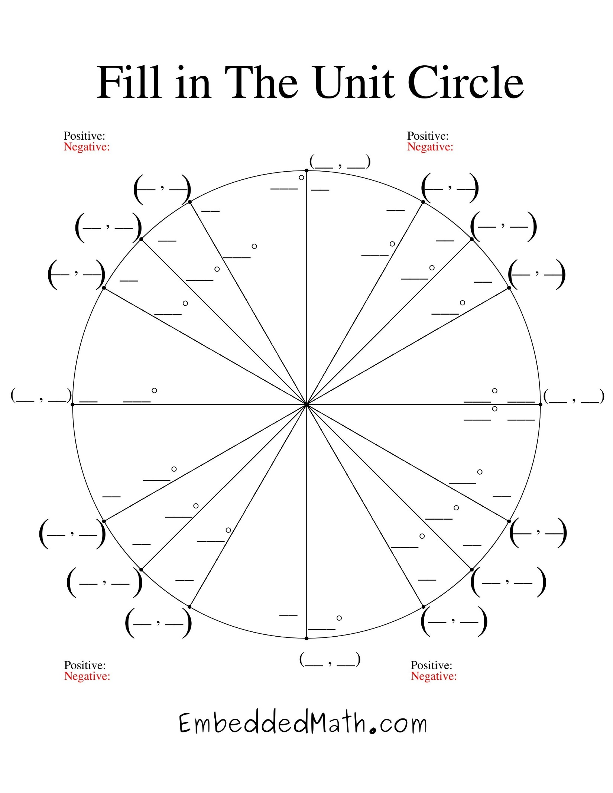

AP Calculus Self-Teaching:

The ability to teach yourself a mathematics topic is a skill that will be both necessary and invaluable throughout college and the rest of your life. It will also be necessary in AP Calculus as the amount of material and limited amount of time require students to become masters of their own education. To practice learning independently, begin to study the first few topics of Calculus. You are free to use any resources you want in order to master the topics listed below. When you feel you are ready, complete the following problems. I have included the answers to the odd-numbered problems. Use these to help check your work.

Topics:
- Limits
- One-sided limits
- Infinite limits
- Limits at infinity
- Finding limits from a graph

Helpful Sites:

http://khanacademy.org/

https://www.youtube.com/user/ThatTutorGuy

http://www.youtube.com/user/ebalzarini - p/c/986560CD1E2A2981

http://www.mathtv.com/

http://hippocampus.org/Calculus

http://www.cliffsnotes.com/WileyCDA/CliffsReviewTopic/Calculus.topicArticleId-39909.html

http://www.calculus-help.com/

Limits:

1. $\lim_{x→2}{\frac{x^{2}-4}{x-2}}$ 2. $\lim_{x→3}{\frac{x^{2}-4x+3}{x-3}}$

3. $\lim_{x→4}{\frac{x-4}{x}}$ 4. $\lim_{x→1}{\frac{x^{3}-4}{x}}$

5. $\lim_{x→0}{\frac{x^{2}-x-2}{x^{2}-2x}}$ 6. $\lim_{x→0}{\frac{\sin{3x}}{x}}$

7. $\lim_{x→0}{\frac{{\left(6+x\right)}^{2}-36}{x}}$ 8. $\lim_{x→4}{\frac{\sqrt{x}-2}{x-4}}$

9. $\lim_{x→8}{\frac{2x^{2}-17x+8}{8-x}}$ 10. $\lim_{x→-3}{\frac{\sqrt{2x+22}-4}{x+3}}$

Finding Limits from Graphs:
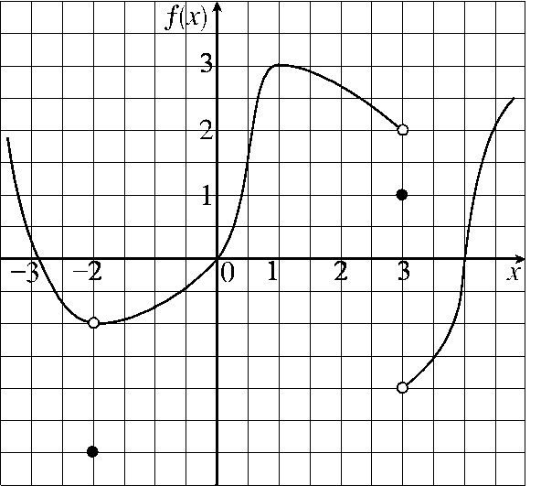

1. $\lim_{x→3^{-}}{f(x)}$ 2. $\lim_{x→3}{f(x)}$ 3. $\lim_{x→-2^{+}}{f(x)}$

4. $\lim_{x→4}{f(x)}$ 5. $\lim_{x→-2}{f(x)}$ 6. $\lim_{x→0}{f(x)}$

7. $f\left(-2\right)=$ 8. $f\left(3\right)=$

One-Sided Limits:

$$g\left(x\right)=\left\{\begin{aligned}2x+5, x<3 \\ x^{3}-8x+1, x>3\end{aligned}\right.$$

1. $\lim_{x→3^{+}}{g(x)}$ 2. $\lim_{x→3^{-}}{g(x)}$

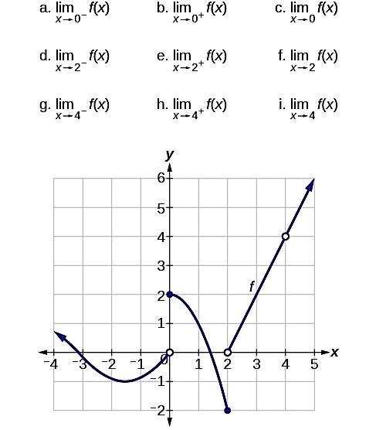

Infinite Limits:

$f\left(x\right)=\frac{2x}{6+x}$ $g\left(x\right)=\frac{x+3}{{\left(1+x\right)}^{2}}$ $h\left(x\right)=\frac{x+7}{x^{2}-4}$

1. $\lim_{x→-6^{-}}{f(x)}$ 2. $\lim_{x→-6^{+}}{f(x)}$ 3. $\lim_{x→-6}{f(x)}$

4. $\lim_{x→-1^{-}}{g(x)}$ 5. $\lim_{x→-1^{+}}{g(x)}$ 6. $\lim_{x→-1}{g(x)}$

7. $\lim_{x→2^{-}}{h(x)}$ 8. $\lim_{x→2^{+}}{h(x)}$ 9. $\lim_{x→2}{h(x)}$

Limits at Infinity:

1. $\lim_{x→∞}{4x^{7}-18x^{3}+9}$ 2. $\lim_{x→-∞}{4x^{7}-18x^{3}+9}$

3. $\lim_{x→∞}{\frac{8-4x^{2}}{9x^{2}+5x}}$ 4. $\lim_{x→-∞}{\frac{8-4x^{2}}{9x^{2}+5x}}$

