**Find the average rate of change for each of the following graphs over the given interval.**

1. [-1, 1] 2. [0, 3] 3. [1, 2]

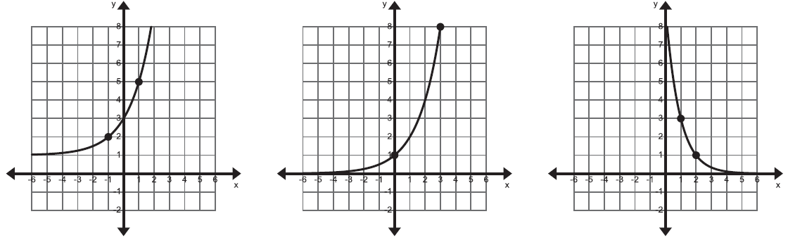

4. [0, 3] 5. [-3, -1] 6. [0, 1]

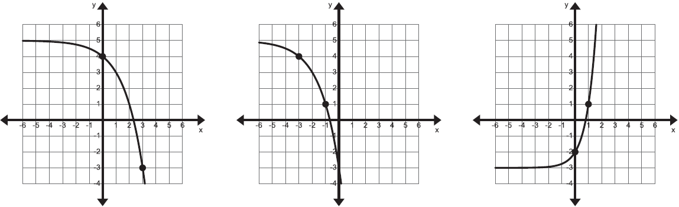

**Suppose 25 flour beetles are left undisturbed in a warehouse bin. The beetle population doubles in size every week. The equation can be used to determine the number of beetles after x weeks. Complete the table.**

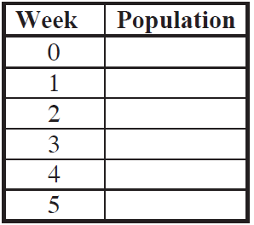

1. Calculate the average growth rate between weeks 1 and 3.
2. Calculate the average growth rate for the first five weeks [0, 5].
3. Which average growth rate is higher? Why do you think it is higher?

**The graph below shows the United States population from 1900 to 2010, as recorded by the U.S. Census Bureau.**

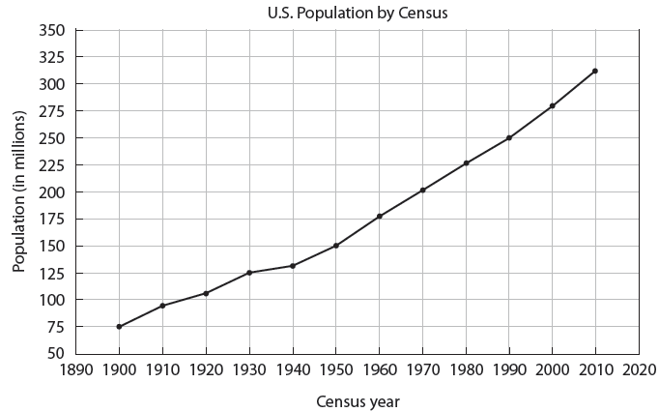

1. What was the rate of change in the population from 1900 to 2000? Is this greater or less than the rate of change in the population from 2000 to 2010?
2. Which 10-year time periods have the highest and the lowest rates of change? How did you find these?

**Find the rate of change of Pete’s height from 3 to 5 years.**

|  |  |  |  |  |  |  |
| --- | --- | --- | --- | --- | --- | --- |
| Time (years) | 1 | 2 | 3 | 4 | 5 | 6 |
| Height(in.) | 27 | 35 | 37 | 42 | 45 | 49 |

1. **For** **, find the rate of change on the interval [-2, 4].**