You have studied linear functions in the past we will briefly review.

There are 2 equations that represent a linear functions:

1. Slope intercept form :

m represents ________________________________________

b represents _________________________________________

1. Standard form: $AX+BY=C Where A, B and C are constants$

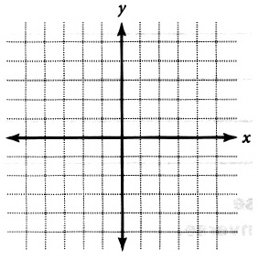Section1:

1. Plot the following points on the graph:

A (-3, -2)

B (0, 4)

C (2, -1)

D (6, 3)

1. What are the coordinates of the following points on the graph:

 A =

B =

C =

D =

1. Complete the table for the equation below: x – 2y = 8

|  |  |  |  |  |  |
| --- | --- | --- | --- | --- | --- |
| X | -2 | 0 | 2 | 4 | 7 |
| Y |  |  |  |  |  |

1. Complete the table for the equation below: 2x +3y = 6

|  |  |  |  |  |
| --- | --- | --- | --- | --- |
| X | -3 | 0 | 2 | 6 |
| Y |  |  |  |  |

Section 2:

Put in slope intercept form (solve for y) :

$8x+2y=2$

$2x-y=8$

$6x-\frac{1}{2}y=10$

1. What are the 3 slopes for the above equations?

5.____ 6.______ 7._____

1. Which of these 3 slopes would *increase* the fastest?
2. Write any linear equation in Standard form. ___________________=_______
3. Using your equation from 10 write it in Slope intercept form.

Section 3 Graphing:

Graph equations 1, 2 &3 on the plane provide below.

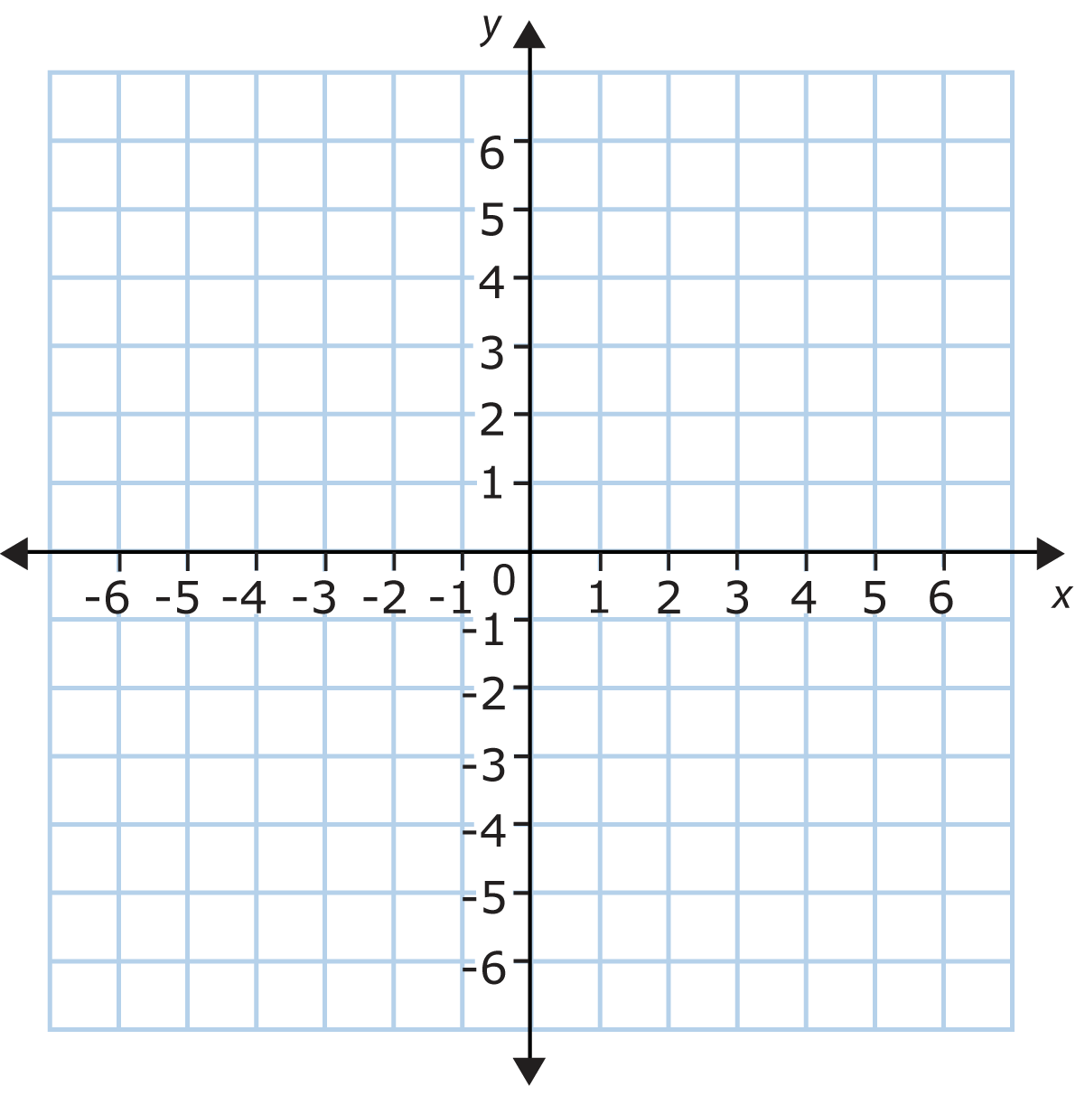

1. Graph, $y=2x-4$, solid
2. Graph, $y=\frac{1}{2}x+1$, dashed
3. Graph, $y=x-1$, shapes

Graph 4 and ***create*** two other linear functions (5&6) one with a steeper slope and one with and less steep slope.

1. Graph $-\frac{1}{2}x+y=2$
2. _____________________
3. _____________________

Slope: ____________________________________________

All linear functions have a slope.

$f(x)=2x+4$ $g(x)=2x-9$ $h\left(x\right)= -\frac{1}{2}x+6$

1. Write the slope for each linear function.
2. Which two functions are parallel? Explain how you know.
3. Which function is perpendicular to the rest? What in the function indicates that is it perpendicular?
4. What does it mean to be perpendicular?

In the chart below create 6 functions 3 must be parallel to each other and at least 2 must perpendicular, but not to the 3 parallel lines .

|  |  |
| --- | --- |
|  |  |
|  |  |
|  |  |

1. Explain what a function is in your own words.

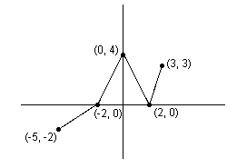

In your groups answer the following questions:

1. Is the graph to the right a function?
2. If so (or if not) how do you know?
3. What is the furthest point to the left(x-value) on this graph? What is the furthest point to the right?

Left most x-value: Right most x-value:

The set of x values between left most and right most point, is called the _________________. So the __________________ for this graph is between

1. What is the lowest point (y-value) on this graph? What is the highest point?

Minimum y-value: Maximum y -value:

The set of y values between lowest and highest most point, is called the _________________. So the __________________ for this graph is between

Unlike **Domain** where the ***end points*** of a continuous function are the values in our set. The Range can be any point. Notice on the graph the lowest point corresponds to the left most point, however the highest point (maximum) is **not the right most point** it is in the middle of the graph.

Notes:

This the function f(x) this is read “f of x”, the x represents the independent variable. We can also think of them as the inputs.

Example: $f\left(x\right)=3x+5$

1. A. How would you say “f (2)”? B. Evaluate.
2. A. How would you say “f(-1)”? B. Evaluate.
3. A. How would you say “f(a+b)”? b. Evaluate.

**Evaluating functions from a graph:**

Use the graph to the right to answer the 4 to 7.

1. 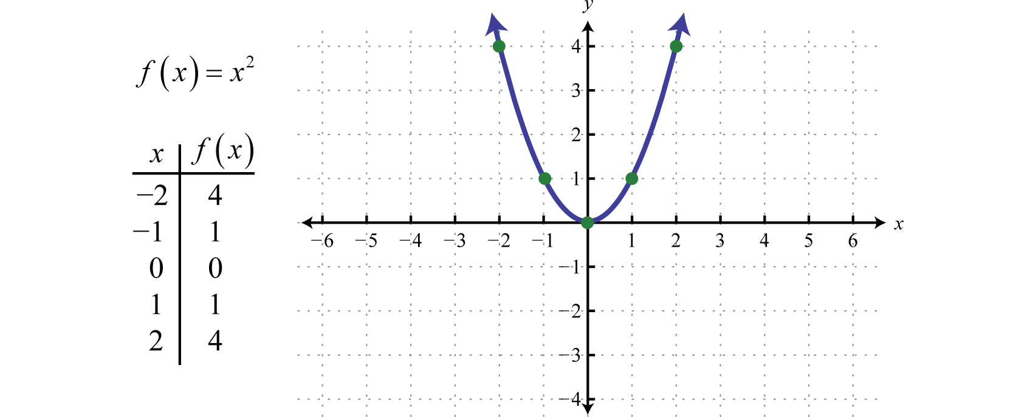Is this graph a function?
2. What is the domain?
3. What is the range?

To evaluate a function from a graph such as f(2) you find where x=2 and then look to see where the graph is at that point.

So in this case f(2) = 4 4 is the output of the x value.

Evaluate the function above:



$f\left(1\right)=$

$f\left(0\right)=$

$f\left(-1\right)=$

$f\left(-2\right)=$

**AFM - Functions**

**Relation:**

**Function:**

**Domain:**

**Range:**

**Evaluate:**

Example 1. Let f(x) = x2.

a. Evaluate f (3), f (-2) and f ($\sqrt{5}$).

b. Find the domain and range of f(x).

Example 2. Let f(x) = 3x2 + x – 5. Evaluate the following:

f(-2) f(0) f(4) f $\left(\frac{1}{2}\right)$

**Piecewise function:**

Example 3. Evaluate the following function at x = -2, 1, 2, 3.

f(x) = $\left\{\begin{aligned}1-x if x≤1 \\ x^{2} if x>1\end{aligned}\right.$

Example 4: Let f(x) = 2x2 + 3x – 1. Evaluate the following:

f(a) f(-a) f(a+h)

**Rules to remember for Domain:**

1. You can only take the square root of positive values, for it to be a valid function.
2. The denominator can never be equal to zero.

**To find domain for unfamiliar functions, work inside out.**

Example 1 : $\sqrt{x^{3}}$

1 First $x$ is being cubed, any number can be cubed, (Domain is currently all real numbers)

2. Whole thing is being square rooted, only positive values can be square rooted.

Therefore, the domain is all x values greater than 0.

Interval notation: [0, $∞)$

Set notation: $\left\{x\right|x≥0\}$

Example 2: $f\left(x\right)=\frac{14}{\sqrt{x^{2}-9}}$

The function domain deals with the independent variable in this case “x”.

1. First x is being squared, any number can be squared, so the domain is (currently all real).
2. Next 9 is subtracted from $x^{2}$, any number can have 9 subtracted from it. (Still all real)
3. Third the whole things is being square rooted, only positive numbers can be square rooted, we need to find all value that make the inside “ $x^{2}-9$” positive

* Solve $x^{2}-9=0$, $x^{2}=9$ $x=+3 or-3$
* **(**Any number less than or equal to -3 and any number greater than or equal to 3 is part of the domain.)

1. Lastly the x’s are in the denominator, so we know that x cannot equal -3 or 3 because that would make the denominator equal zero.

Therefore, the domain is all values that are less than -3 and greater than positive 3.

Example 2 Continued:

Interval notation: $\left(-∞,-3\right)∪\left(3,+ ∞\right)$

Set notation: $\left\{x\right| x<-3 and x>3\}$

You Try: Find the domain of each function.

1. 2) 3)

D: D: D:

4) 5 6)

D: D: D:

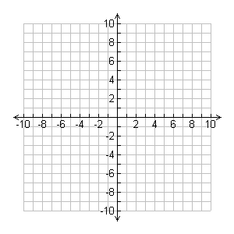Sketch the following functions:

1. $y=t^{2}$**2) $y=x^{3}$**



Continue sketching

3. 4.



1. 6.



